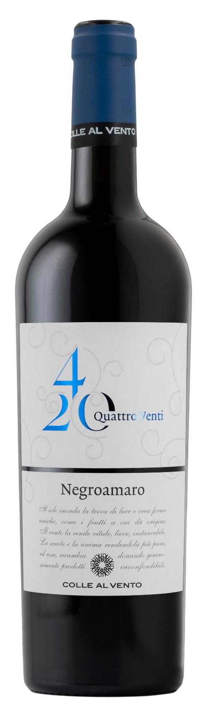
NEGROAMARO SALENTO IGP – 4/20

Grape: Negroamaro 100%
Alc. Vol.%: 13,5
Vintage: 2024
Residual sugar g/l: 6,9
Total acidity g/l: 5,7
Region: Apulia
Production zone: Southern Apulia, Salento Area (Lecce and Brindisi)
Capacity: 750ml

CHARACTERISTICS

Vinification: After a soft pressure and the separation of grape-stalk, 10-14 days of classic peel maceration at a controlled temperature
Aging: Steel tanks
Total production: 12000kg
Colour: Deep, intense red
Bouquet: Harmonious with pleasant aroma of juniper
Flavour: Full bodied and elegant with well-amalgamated tannins

SERVING SUGGESTIONS

Best enjoyed with savoury pasta and grilled meat.
Serving temperature 16-18 °C
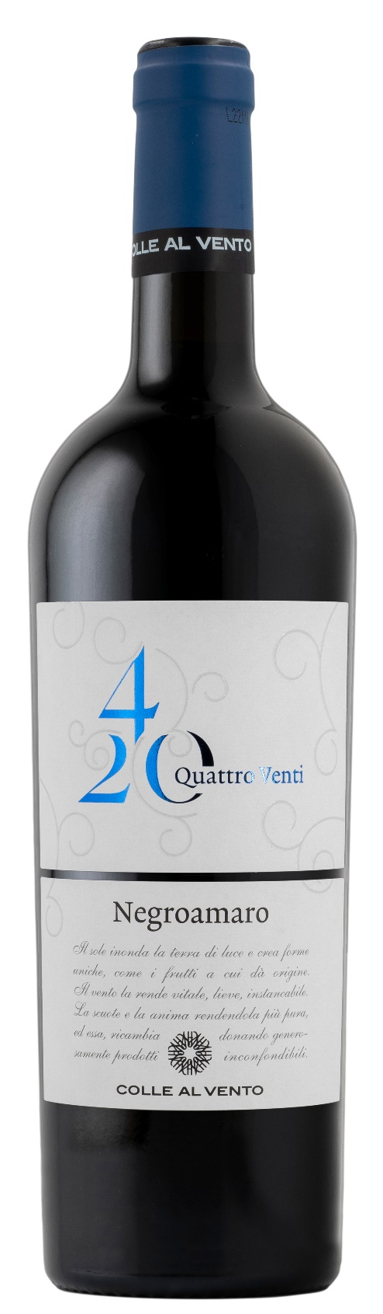
TECHNICAL INFORMATION / PALLETIZING

Size 750ml:
Article Nr. V03009A
GTIN-13 bottle 8017868002017
GTIN-13 carton 8017868001775
Closure Cork
Bottles / carton 6 bottles
Pallet size 80x120cm
Cartons/layer 21
Cartons/pallet 105
Kg/carton 7,8
Kg/pallet 840

Contains sulphites
GMO Free
Revisione 01. 14.05.2026

